

Wisconsin Power & Light Solar Energy Projects
Wood County
Saratoga, Wisconsin



Implementation Date:

Review/Revision Date:

Approved By: | Title: | Date: | Effective Date:
Approved By: |  |  | Review Date:
Approved By: |  |  | Supersedes:

Table of Contents

Emergency Action Plan

Page
1.0 Purpose…………………………………………………………………………………..3
1.1 Emergency Contact Information / Important Project Numbers……………3
2.0 Types of Emergency Evacuations 4
2.1 Types of Alarms 4
3.0 Employee Training 4
4.0 Fire Prevention Plan 5
4.1 Fire and Emergency Reporting 5
4.2 Maps…………………………………………………………………………….5
4.3 Emergency Evacuation Procedures and Assignments…………………….5
5.0 Tornado Procedures 6
6.0 Rescue and Medical Duty Assignments 6
7.0 Critical Plant Procedures 7
8.0 Emergency Coordinator 7

Appendix A - Map to Hospital (Emergency Room) 8
Appendix B - Map to Occupational Clinic 9
Appendix C - Map of Emergency Evacuation Routes 10

1.0 Purpose

It is Burns & McDonnell’s policy to protect its personnel, community, and environment. As such, this facility maintains an Emergency Action Plan (EPA) which details procedure to prevent and minimize hazards to human health and environment. This written document is prepared to demonstrate compliance with 29CFR 1910.38.

The Plan addresses medical emergencies and emergencies resulting from fire, explosion, bomb threats, civil disturbances, weather, and any potential release of toxic chemicals. The provisions of the Plan will be implemented during any event, which may threaten human health or the environment.
1.2 Contact Information

Emergency Information
Emergency Call 911
Hospital (Emergency Care):  Aspirus Riverview Hospital  410 Dewey St  Wisconsin Rapids, WI 54494  +1715-423-6060  *Map / Directions can be found in Appendix A* | United Emergency Med Response  Ambulance service  Wisconsin Rapids, WI  (715) 423-7777
Fire Department:  Wisconsin Rapids Fire Department  1511 12th St S,  Wisconsin Rapids, WI 54494  (715) 423-1150 | Law Enforcement Agency:  Wisconsin Rapids Police Department  444 W Grand Ave,  Wisconsin Rapids, WI 54495  (715) 423-4444
Poison Control Center: 1-800-222-1222
Environmental Emergencies
National Response Center / USEPA: 1-800-424-8802
Name of ContractorSpill Response Service: Telephone Number
Occupational Clinic Information
Occupational Clinic
Aspirus Riverview Hospital
410 Dewey St
Wisconsin Rapids, WI 54494
+1715-423-6060
*Map / Directions can be found in Appendix B*
Important Project Numbers
Senior Project Manager: Seth Hanebutt |  | 816-822-4381 | 816-223-0999
Project Manager: Bob Fayard |  | 816-822-4275 | 816-309-2593
Field Site Manager: Name |  | Office Number | Mobile Number
Site Safety & Health Manager: Name |  | Office Number | Mobile Number
Corporate Safety & Health Manager: Michael Korte |  | 816-708-1089 | 816-743-1721
Certified Industrial Hygienist: Eric Wenger |  | 816-822-3894 | 913-313-7954
Workers Compensation: Logan Graybill |  | 816-605-7722 | 816-820-5187
Safety Equipment Manager: Kayce Holloway |  | 816-447-9861 | NA
ONE CALL |  | 811

2.0 Types of Emergency Evacuations:

At this location, the following types of emergencies exist:
- Fire or Explosion
- Medical Emergency
- Severe Weather
- Tornado
- Flooding
- Toxic Chemical Release
- Workplace Violence
- Bomb Threat

2.1 Types of Alarm Tones:

Verbal Communication

Air Horn

Cell Phone

Radio

3.0 Employee Training

Employees shall be trained in safe evacuation procedures during orientation, and refresher training shall be conducted whenever the employee’s responsibilities or designated actions under the plan change or whenever the plan itself is changed. The employer shall review with each employee upon
initial assignment the parts of the plan which the employee must know to protect the employee in the
event of an emergency. The training shall include the use of floor plans and workplace maps which clearly shows the emergency escape routes included in the Emergency Action Plan.

4.0 Fire Prevention Plan

The Fire Prevention Plan has been established to control and reduce the possibility of a fire and to
specify the type of equipment required to be available in case of a fire.

In addition, smoking is only allowed in posted designated smoking areas.
.
The smoking area(s) for this location are:
Office Trailers (designated area outside) | Craft Break Trailer (designated area)

4.1 Fire and Emergency Reporting Procedures
In the event of a fire and/or any other type of emergency, the following reporting procedures shall be
followed.

When a fire is detected activate the alarm system immediately to notify all personnel.

Personnel shall verify what type of alarm is sounding. Then, act accordingly to the alarm. The
Emergency Coordinator or their designee shall contact the local fire department.

The local fire department will perform all emergency rescue and firefighting duties. The Emergency Coordinator or their designee shall meet with the fire department to give them information concerning the emergency and to notify them of any missing persons.

4.2 Maps

Maps have been developed for this project to show the emergency evacuation routes. These maps are posted in common areas of the project to provide guidance in an emergency. A copy of the floor plan and maps are in Appendix C.

4.3 Emergency Evacuation Procedures and Assignments

- Should evacuation of the project be required, the following procedures shall be followed to ensure safe evacuation of all personnel.
- The Emergency Coordinator shall utilize the alarm system or means of communication (e.g., air horn, Cell phone, radio, etc.) to effectively communicate that evacuation of the project is required.
- The Emergency Coordinator shall notify the local emergency services of the emergency and type of response needed.
- Personnel shall proceed to the nearest available and safe exit or refuge zone as quickly as possible.
- Personnel operating moving machinery (trucks, forklifts, hand tools, etc.) shall shut equipment off in a safe manner and proceed to the nearest refuge zone.
- Personnel shall gather at a refuge zone. The refuge zones will provide sufficient space to accommodate the employees. During evacuation procedures personnel shall move away from the exit discharge doors of the building and avoid congregating close to the building(s) or where they might hamper emergency operations.
- The Emergency Coordinator shall verify that the visitor log has been removed from the building.
- The Emergency Coordinator shall conduct a head count to verify that all personnel have been safely evacuated.
- The Emergency Coordinator shall communicate to the fire department either that all personnel have been safely evacuated or who remains unaccounted for.
- After the determination has been made, that return to work is safe, by the Emergency Coordinator, employees may return to work.

Refuge Zones
Area | Designated Refuge Zone
Site Wide | Primary – Project Site Office Trailers  Secondary – Contractor Parking Lot

5.0 Tornado Procedures
Weather is monitored by computers, portable weather stations and / or cell phones. If a tornado warning or watch has been issued by local weather services(s), the Emergency Coordinator shall notify all employees. Should evacuation be required, personnel shall evacuate to the nearest shelter.

The area(s) which have been designated to provide shelter during a tornado is as follows.
Department / Area | Designated Refuge Zone
TBD upon mobilization

6.0 Rescue and Medical Duty Assignments

Should rescue be required, the local emergency service responding to the emergency is responsible for performing any rescue.

Designated personnel who have been trained in first aid and cardiopulmonary resuscitation (CPR) and provided medical assistance within their capabilities.

Personnel who have received First Aid / CPR training are:
TBD upon mobilization

NOTE:
Professional emergency services responding to an emergency will assist with and direct all rescue and medical duty assignments upon their arrival.

7.0 Critical Plant Procedures
The procedure taken to care for essential plant operations until a total evacuation becomes absolutely necessary include:
Monitoring the Project Power Supply
Monitoring Water Supplies
Maintaining Communication Systems

8.0 Emergency Coordinator
There shall be at least one Emergency Coordinator for every twenty employees in the workplace to provide guidance and instruction at the time of the evacuation. The employees selected shall be trained in the workplace layout and various escape routes from the workplace.

Emergency Coordinators for this project and/or building are:
TBD upon mobilization

All Emergency Coordinators shall be made aware of.

Any physically handicapped employees who may require additional assistance and hazardous areas to avoid during emergencies.

Any visitors or personnel who are not permanently assigned to the project and / or building.

Appendix A
Map / Direction to Hospital (Emergency Room)

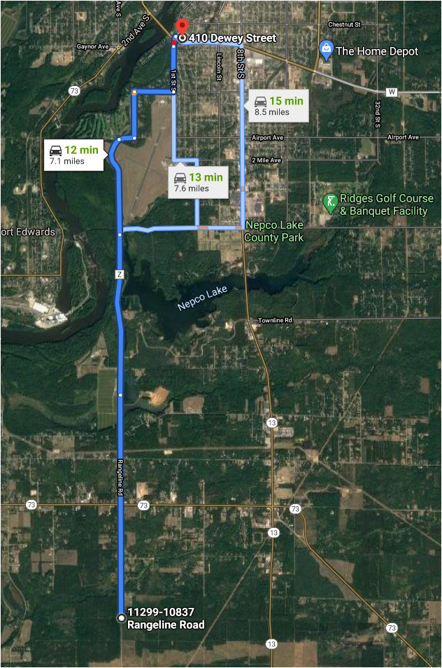

Head north on Rangeline Rd toward Bornbach Rd
4 min (2.5 mi)

Continue onto County Hwy Z/County Rd Z
2 min (1.8 mi)

Continue on Rangeline Rd to Wisconsin Rapids
4 min (2.2 mi)

Drive
2 min (0.6 mi)

Turn right.
Destination will be on the left.
22 s (400 ft)
410 Dewey St
Wisconsin Rapids, WI 54494
Appendix B
Map / Directions to Occupational Clinic

Head north on Rangeline Rd toward Bornbach Rd
4 min (2.5 mi)

Continue onto County Hwy Z/County Rd Z
2 min (1.8 mi)

Continue on Rangeline Rd to Wisconsin Rapids
4 min (2.2 mi)

Drive
2 min (0.6 mi)

Turn right.
Destination will be on the left.
22 s (400 ft)
410 Dewey St
Wisconsin Rapids, WI 54494
Appendix
Map / Emergency Evacuation Routes

