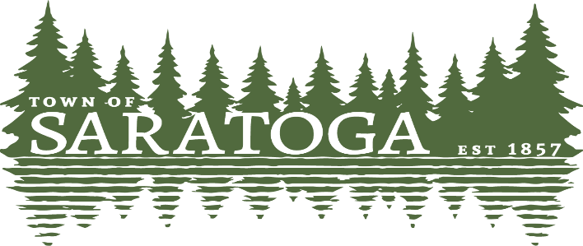
WOOD COUNTY, WISCONSIN
____________________________________________________________________________

The Saratoga Town Board will meet at the Town of Saratoga Office Board Room,
1120 State Highway 73 South, Wisconsin Rapids, on
Monday October 3, 2022 at 6:00 p.m.
The agenda follows:
- Convene in open session
- Pledge of Allegiance
- Discuss the preparation of the budget, priorities and needs.
- Adjourn

Paulette Weinfurter Clerk Posted: 9/30/2022
This meeting may be recorded.

