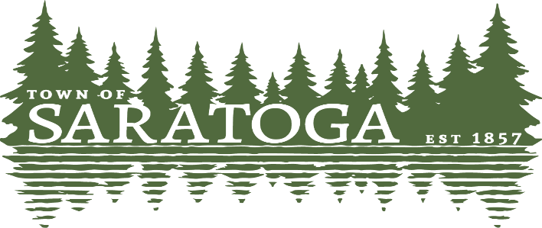
WOOD COUNTY, WISCONSIN
_____________________________________________________________________________________________

Plan Commission Meeting Agenda

Wednesday, September 13th, 2023 at 6:00 p.m.
Meeting will take place at the Town Hall 1120 State Hwy 73 S.

- Convene in open session.
- Call to order and declaration of quorum.
- Public comment (rules may apply).
- Approve minutes for August 9th, 2023 meeting.
- Discuss Kevin Foley CSM.
- Discuss Shawn Weber CSM.
- Review Historic Point Basse proposal of old town hall preservation and
moving to Wakely site.
- Review updates and proposed revisions to current mobile home and
touring/recreational vehicles ordinance.
- Information and announcements from PC members.
- Set our next meeting date.
- Adjourn.

9/8/2023 Paulette Weinfurter-Clerk

