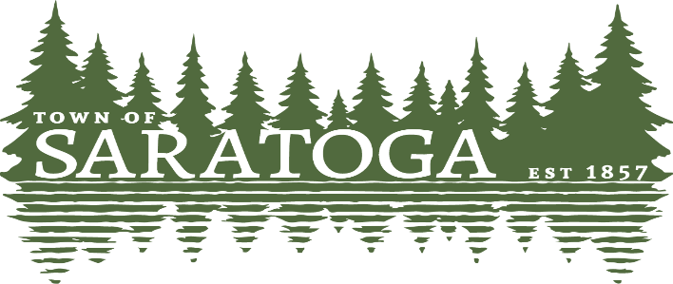
WOOD COUNTY, WISCONSIN
____________________________________________________________________________

The Saratoga Town Board will meet at the Town of Saratoga Administrative Building,
1120 State Highway 73 South, Wisconsin Rapids, on
Wednesday, October 4th, 2023 at 4:30 p.m.
The agenda follows:

- Convene in open session
- The board will go into closed session pursuant to Wis §19.85(1)(c) Considering employment, promotion, compensation, or performance evaluation data of any public employee over which the governmental body has jurisdiction or exercises responsibility. The purpose of this session is to discuss compensation and benefits of a Town Employee.
- The Board reserves the right to come out of Closed Session and return into Open session authorized by Wis.§19.85(2): No Governmental body may commence a meeting, subsequently convene in closed session and thereafter reconvene again in open session withing 12 hours after completion of the closed session, unless public notice of such subsequent open session was given at the same time and in the same manner as the public notice of meeting convened prior to the closed session.
- Adjourn
Paulette Weinfurter-Clerk Posted 10/2/2023

